|  |
| --- |
| **NUTRITION ASSISTANT APPLICATION** |
| **PROJECT REPORT**  **Submitted by** |
| **TEAM ID**  PNT2022TMID12243  **TEAM MEMBERS**  AJITHA.M-920419UCSE004  PONMATHI.R-920119UCSE025  NANTHINI.K-920419UCSE077  ASHIFA PARVEEN.A-920419UCSE095  **from**  KAMARAJ COLLEGE OF ENGINEERING AND TECHNOLOGY |

CONTENT

# INTRODUCTION

* 1. Project Overview
  2. Purpose

# LITERATURE SURVEY

* 1. Existing problem
  2. References
  3. Problem Statement Definition

1. IDEATION & PROPOSED SOLUTION
   1. Empathy Map Canvas
   2. Ideation & Brainstorming
   3. Proposed Solution
   4. Problem Solution fit

# REQUIREMENT ANALYSIS

* 1. Functional requirement
  2. Non-Functional requirements

# PROJECT DESIGN

* 1. Data Flow Diagrams
  2. Solution & Technical Architecture
  3. User Stories

# PROJECT PLANNING & SCHEDULING

* 1. Sprint Planning & Estimation
  2. Sprint Delivery Schedule
  3. Reports from JIRA

1. CODING & SOLUTIONING
   1. Feature 1
   2. Feature 2
   3. Database Schema (if Applicable)

## TESTING

* 1. Test Cases
  2. User Acceptance Testing

## RESULTS

* 1. Performance Metrics

## ADVANTAGES & DISADVANTAGES

1. CONCLUSION

## FUTURE SCOPE

1. APPENDIX

Source Code

GitHub & Project Demo Link

1. INTRODUCTION

## Project Overview

Currently, we see how on TV, on social networks, in the press, on blogs, etc., famous people and advertising that promote a healthy lifestyle and proper nutrition. These things have become especially prevalent in the pandemic when everyone has been isolated at home and because of stress and sedentary lifestyle people have either gained unwanted pounds or lost too much weight. The current paper describes the Appetite application starting with the motivation and similar applications, continuing with the architecture and details about the main functionalities.

* 1. Purpose

Nutrition assistants **help dieticians with providing proper nutrition at healthcare facilities**. They determine patients' nutritional needs, assess risk factors, and plan meals and menus. They also ensure proper sterilization of plates and utensils.

# LITERATURE SURVEY

* 1. Existing problem

Due to the ignorance of healthy food habits, obesity rates are increasing at an alarming speed, and this is reflective of the risks to people’s health. People need to control their daily calorie intake by eating healthier foods, which is the most basic method to avoid obesity. However, although food packaging comes with nutrition (and calorie) labels, it’s still not very convenient for people to refer to App-based nutrient dashboard systems which can analyze real-time images of a meal and analyze it for nutritional content which can be very handy and improves the dietary habits, and therefore, helps in maintaining a healthy lifestyle

This project aims at building a web App that automatically estimates food attributes such as ingredients and nutritional value by classifying the input image of food. Our method employs **Clarifai's AI-Driven Food Detection Model** for accurate food identification and Food API's to give the nutritional value of the identified food.

* 1. References

1. **Name of the paper** :Measuring and influencing physical activitywithsmart phone technology

**Published year** :2014

**Author** : Judit Bort - Roig et al. Sports Med

1. **Name of the paper** : Primary Nutrition Health care.

**Published year** :2020

**Author** : Christian Kraef et al. Bull World Health Organ.

1. **Name of the paper**: Rapid Developments Technology have Encouragedthe use of Smartphone in Health Promotion Research and Practice.

**Published year**: 2015

**Author:** Steven S Coughlin et al. Jacobs J Food Nutr

* 1. Problem Statement Definition

This Nutrition assistant app is based on nutrients and calories of the food will help people with providing proper nutrition and helps in maintaining a healthy lifestyle.Instead of using many different apps to keep touch with people,this one software handle everything ,such as meal planning ,diet

analysis,communiction between client and nutritionists ,workout plans,questionnaries and nutrition coaching for clients Further this will help you to track their progress,keep a food journal,track their water intake.

# IDEATION & PROPOSED SOLUTION

* 1. Empathy Map

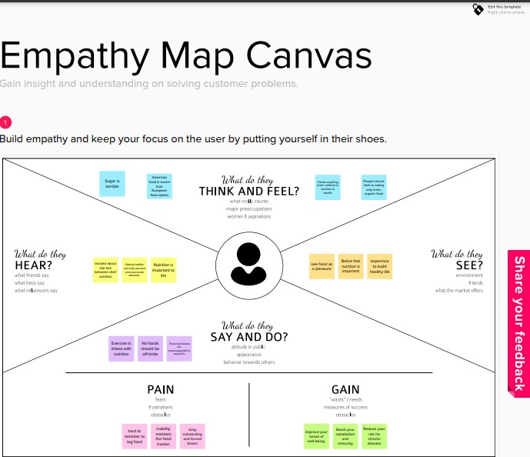

* 1. Ideation & Brainstorming

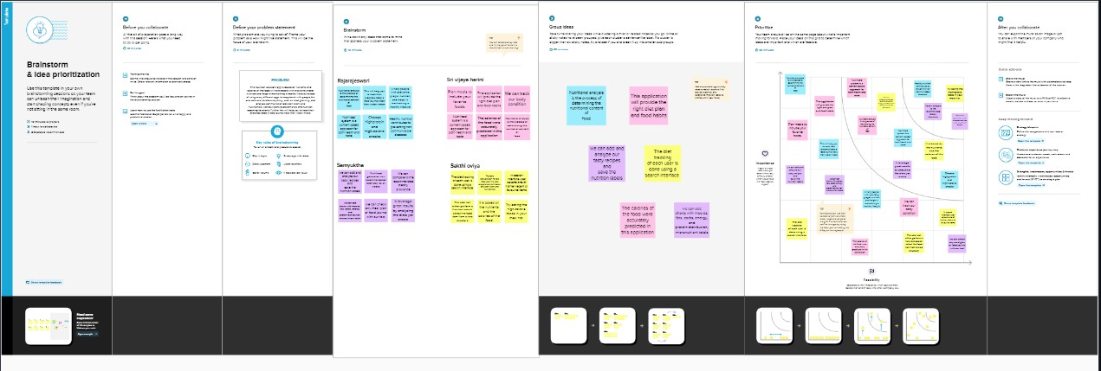

* 1. Proposed Solution

|  |  |  |
| --- | --- | --- |
| S.No | Parameter | Description |
| 1 | Problem Statement | 1. This Nutrition assistant app is based on nutrients and calories of the food will help people with providing proper nutrition and helps in maintaining a healthy lifestyle. 2. Instead of using many different apps to keep touch with people this one .   software handle everything such as meal planning  diet analys is communication between client and nutritionists ,workout plans, questionnaires and nutrition coaching for clients.   1. Further this will help you to track   their progress keep a food journal track their water intake. |
| 2 | Idea / Solution description | 1.By creating an application , we can recommended diet plans for the users and measures sugar level. |
| 3 | Novelty / Uniqueness | 1.I can realize real time images of meal and analyze it for nutritional content can be handy and improve dietary habit. |
| 4 | Social Impact / Customer Satisfaction | 1.It helps to maintain with providing proper nutrition and healthy lifestyle for normal people. |
| 5 | Business Model (Revenue Model) | 1.Social Media is to best way to develop our application. |
| 6 | Scalability of the Solution | 1. Good Relationship .   Easily Access to the Application. 3.Different diet charts can be planned for different aspects of people. |

* 1. Problem Solution fit

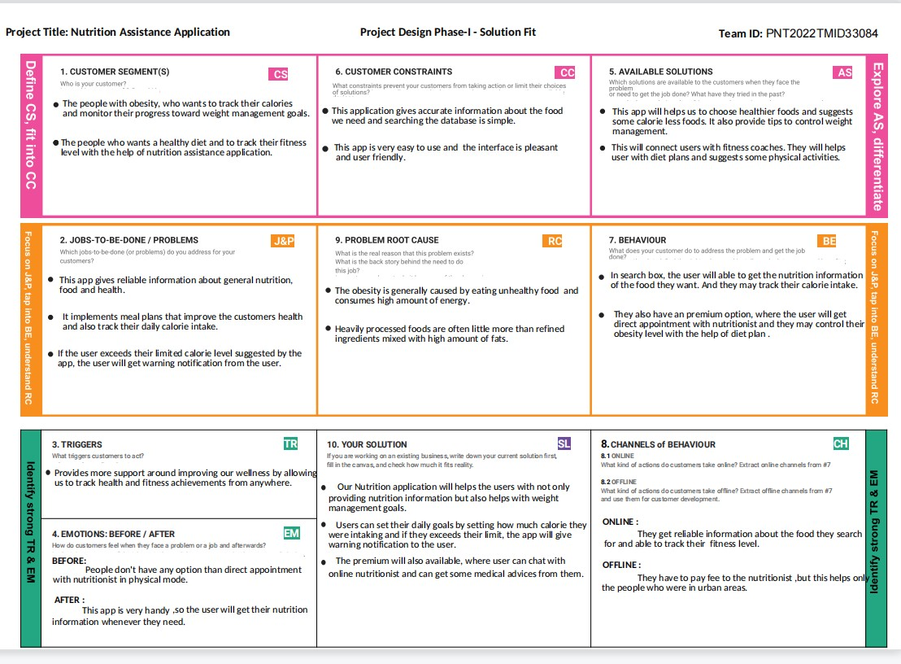

1. REQUIREMENT ANALYSIS
   1. Functional requirement

|  |  |  |
| --- | --- | --- |
| **FR.No** | **Functional Requirement**  **(Epic)** | **Sub Requirement (Story /**  **Sub-Task)** |
| FR-1 | User Registration | Registration through Form. |
| FR-2 | User Confirmation | Confirmation via OTP. |
| FR-3 | Uploading Image | The system should able to get the  image from the user. |
| FR-4 | Identification of image | The system should able to identify the image of the food given using  model. |
| FR-5 | Obtain the ingredients | The system must able to obtain the ingredients of the given food  image. |
| FR-6 | Display the nutritional value | The system must able to display the nutritional value of the food with the help of nutritional  Application |

* 1. Non-Functional requirements

|  |  |  |
| --- | --- | --- |
| **FR.No** | **Non-Functional Requirement** | **Description** |
| FR-1 | Usability | Only registered user is allowed to using the application. |
| FR-2 | Security | Authentication of user is done for security purpose. |
| FR-3 | Reliability | The user gets the standardized nutritional value of the food items. |
| FR-4 | Performance | User satisfaction is ensured by getting their feedback . |
| FR-5 | Availability | This application can be used by the user when they are in online Mode. |
| FR-6 | Scalability | This application can be used in all operating system and it can handle quite large Quantity of users too. |

## PROJECT DESIGN

* 1. Data Flow Diagrams

A Data Flow Diagram (DFD) is a traditional visual representation of the information flows within a system. A neat and clear DFD can depict the right amount of the system requirement graphically. It shows how data enters and leaves the system, what changes the information, and where data is stored.

Example: DFD Level 0

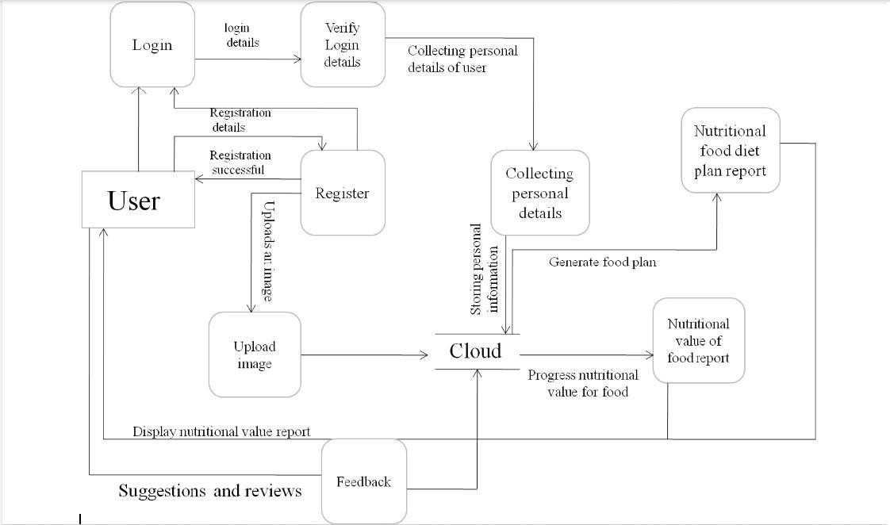

* 1. Solution & Technical Architecture

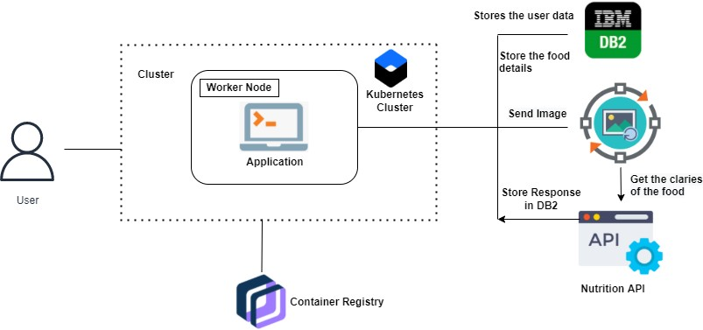

* 1. User Stories

|  |  |  |  |  |  |  |
| --- | --- | --- | --- | --- | --- | --- |
| User Type | Functional Requirement  (Epic) | User Story Number | User Story  / Task | Acceptance criteria | Priority | Release |
| Customer (Mobile user) | Registration |  | As a user, I can register  for the | I can access my account / dashboard | High | Sprint-1 |
|  |  | application |  |  |  |
|  |  | by entering |  |  |  |
|  |  | my email, |  |  |  |
|  |  | password, |  |  |  |
|  |  | and |  |  |  |
|  |  | confirming |  |  |  |
|  |  | my |  |  |  |
|  |  | password. |  |  |  |

|  |  |  |  |  |  |  |
| --- | --- | --- | --- | --- | --- | --- |
|  |  |  | As a user, I will receive confirmation email once I have | I can receive confirmation email & click confirm | High | Sprint-1 |
| registered for the application |  |  |  |
|  | Login |  | As a user, I | I can login when password and email are correct | High | Sprint-1 |
|  | can log into |  |  |
|  | the |  |  |
|  | application |  |  |
|  | by entering |  |  |
|  | email & |  |  |
|  | password |  |  |
|  | Collecting |  | As a user,I | I can enter | Medium | Sprint-1 |
| personal | can provide a | the personal |  |  |
| details | personal | details |  |  |
|  | information |  |  |  |
|  | for |  |  |  |
|  | processing |  |  |  |
|  | Upload image |  | As a user,I | I can upload | High | Sprint-1 |
|  | can upload | a food image |  |  |
|  | an image for |  |  |  |
|  | the |  |  |  |
|  | processing of |  |  |  |
|  | food. |  |  |  |
|  | Feedback |  | As a user,I | I can give | Low | Sprint-1 |
|  | can give | feedback |  |  |
|  | feedback | about the |  |  |
|  |  | application |  |  |
| Cloud | Nutritional |  | In cloud the | It gives the | High | Sprint-2 |
|  | value of report | food image is | nutritional |  |  |
|  |  | processed | value of |  |  |
|  |  | and provides | food. |  |  |
|  |  | the |  |  |  |
|  |  | nutritional |  |  |  |
|  |  | value of |  |  |  |
|  |  | food. |  |  |  |
|  | Nutritional food diet plan report |  | In cloud the food diet plan based | It provides the diet | Medium | Sprint-2 |

|  |  |  |  |  |  |  |
| --- | --- | --- | --- | --- | --- | --- |
|  |  |  | on nutritional value is generated based on the personal information provided by the user. | nutritional plan. |  |  |

# PROJECT PLANNING & SCHEDULING

* 1. Sprint Planning & Estimation

|  |  |  |  |  |  |  |
| --- | --- | --- | --- | --- | --- | --- |
| Sprint | Functional  Requirement (Epic) | User  Story Number | User Story / Task | Story Points | Priority | Team Members |
| Sprint-1 | prerequisites for model building |  | As a developer I have to collect the different type of data possible and other data supporting  the model | 2 | High |  |
| Sprint-1 | Registration |  | As a user, I can register for the application by entering my email, password, and confirming my password | 2 | High |  |
| Sprint-1 |  |  | As a user, I will receive confirmation email once  I have registered for the application | 1 | High |  |
| Sprint-1 | Gmail Registration |  | As a user, I can register for the application through Gmail | 2 | Low |  |

|  |  |  |  |  |  |  |
| --- | --- | --- | --- | --- | --- | --- |
| Sprint-2 | Login |  | As a user, I can log into the application by entering email &  password | 1 | High |  |
| Sprint-2 | Suggestion |  | As a user now I can make recommendations such as nutrition plans,diet plans etc.. | 1 | Low |  |
| Sprint-2 | Model building |  | Development of the model with the prepared data | 2 | High |  |
| Sprint-2 | Main interface |  | As a user i can view my calories by uploading  the photo of the food that I want to eat | 2 | High |  |

|  |  |  |  |  |  |  |
| --- | --- | --- | --- | --- | --- | --- |
| Sprint | Functional Requirement  (Epic) | User Story Number | User Story / Task | Story Points | Priority | Team Members |
| Sprint-3 | Diet plan for free users |  | As a dietician I provide a diet plans for the betterment of the  user | 2 | High |  |
| Sprint-3 | Diet plans for Premium users |  | As a premium user, I can choose to follow the  diet plan based on my food  habits | 1 | Medium |  |
| Sprint-3 | User image analysis |  | As a user, I can track my calories intake and  know about my  food in detail | 2 | High |  |
| Sprint-3 | Improve the efficiency of AI model |  | As a developer, I can give the better model that | 2 | Medium |  |

|  |  |  |  |  |  |  |
| --- | --- | --- | --- | --- | --- | --- |
|  |  |  | analyse the food and provide the  accurate result |  |  |  |
| Sprint-3 | User analysis record |  | As a user, I can check the records of the food habits | 1 | Medium |  |
| Sprint-4 | Diet tips and basic  plan |  | As a user now I can make recommendations such as nutrition  plans,diet plans etc.. | 1 | Medium |  |
| Sprint-4 | Paymen |  | Develop the payment gateway options for premium users | 2 | High |  |
| Sprint-4 | Dashboard |  | The details will provided via  nutrition AP | 2 | High |  |

* 1. Sprint Delivery Schedule

|  |  |  |  |  |  |  |
| --- | --- | --- | --- | --- | --- | --- |
| Sprint | Total Story Points | Duration | Sprint start time | Sprint End time | Story Points Completed (as on Planned  End Date) | Sprint Release Date (Actual) |
| Sprint-1 | 20 | 6 days | 24 Oct 2022 | 29 Oct 2022 | 20 | 29 Oct 2022 |
| Sprint-2 | 20 | 6 days | 31 Oct 2022 | 05 Nov 2022 | 20 | 04 Nov 2022 |
| Sprint-3 | 20 | 6 days | 07 Nov 2022 | 12 Nov 2022 | 20 | 11 Nov 2022 |
| Sprint-4 | 20 | 6 days | 14 Nov 2022 | 19 Nov 2022 | 20 | 18 Nov 2022 |

* 1. Reports from JIRA

## TESTING

* 1. Test Cases

This reports how’s the number of test cases that have passed, failed, and untested

|  |  |  |  |  |
| --- | --- | --- | --- | --- |
| Section | Total Test Cases | Not Tested | Fail | Pass |
| Print Engine | 7 | 0 | 0 | 7 |
| Client Application | 41 | 0 | 0 | 41 |
| Security | 2 | 0 | 0 | 2 |
| Outsource Shipping | 3 | 0 | 0 | 3 |
| Exception Reporting | 12 | 0 | 0 | 12 |
| Final Report Output | 4 | 0 | 0 | 4 |
| Version Control | 2 | 0 | 0 | 2 |

* 1. User Acceptance Testing

The purpose of this document is to briefly explain the test coverage and open issues of the **Nutrition Assistant Application** project at the time of the release to User Acceptance Testing (UAT).

All the non-control group users were tracking their nutrition using our application. Therefore, we have measures of any food item being consumed, their portion size, and their nutritional values. Furthermore, we track which of the nutrients were focused in the home- screen on the day an item was consumed. The six nutrients shown on the current day are called “focused" nutrients, while all others are “unfocused" for this day.

## RESULTS

* 1. Performance Metric

Cloud performance metrics enable you to effectively monitor your cloud resources, to ensure all components communicate seamlessly. Typically, cloud performance metrics measure input/output operations per second (IOPS), filesystem performance, caching, and autoscaling.Developers don’t have many opportunities to learn how their apps affect people’s health due to privacy protection. In some cases, you can invite users to take a survey to better assess the impact your app has had on them. You can also apply common metrics, connecting them to your app’s purpose.

## ADVANTAGES & DISADVANTAGES

Advantages

* It can cause you to think about and consider a food choice before you take a bite.
* It allows you to analyze your own food choices to assess and tweak your eating plan and patterns.
* It provides general awareness of nutrients in food.
* It is a targeted way to focus on your health.

Disadvantages

* It can actually remove a level of mindfulness because the goal is to hit target numbers NOT listen to your body.
* It’s not sustainable long term.
* We might avoid certain healthy foods that are difficult to add into the food tracker.
* We can become hyper-focused on numbers (calories, carbs, fiber, sugar, etc) over eating a wide variety of healthy, whole foods.

.

## CONCLUSION

With people becoming conscious about their diets and fitness goals, there is a wide scope of diet and fitness apps thriving in the app world. Therefore, this time is pretty much perfect to create a diet and fitness app of your own and enter the market with a unique idea in order to lure the audience towards your app.

For developing a healthcare app, you must be sure of hiring the best team of experts who have prior experience in the same field and can guide you through the development process

## FUTURE SCOPE

In future,Nutrition app plays a vital role in day to day life. Everyone is busy with their work and schedules . Noone cares about their body condition and health issues . So this website will be more useful compared to anyother websites . This site will provide everyday diet and workouts plans to lead healthy and a peaceful life . This site will helps you to be fit by calculating your calories in food when you upload the food picture in the site .Nowadays , Smart watches helps to calculate your blood pressure , stress level , water content level and mainly it helps you to count your foot steps and makes you fit and healthier. Likewise this site will helps people to eat stay healthy.

## APPENDIX

Source Code

# Base.html:

<!DOCTYPE html>

<html lang="en">

<head>

<link rel="shortcut icon" href="/static/assests/logo-removebg-preview.png" type="image/x-icon"/>

<link rel="icon" href="/static/assests/logo-removebg-preview.png" type="image/x-icon"/>

<link rel="apple-touch-icon" href="/static/assests/logo-removebg-preview.png" height="100px">

<link rel="stylesheet" href="{{ url_for('static', filename='style.css') }}">

<link rel="stylesheet" href="https://stackpath.bootstrapcdn.com/bootstrap/4.5.2/css/bootstrap.min.css">

<link rel="stylesheet" href="https://stackpath.bootstrapcdn.com/font-awesome/4.7.0/css/font- awesome.min.css">

<script src="https://kit.fontawesome.com/a076d05399.js"></script>

<script src="https://code.jquery.com/jquery-3.5.1.slim.min.js"></script>

<script src="[https://cdn.jsdelivr.net/npm/popper.js@1.16.1/dist/umd/popper.min.js"><](https://cdn.jsdelivr.net/npm/popper.js%401.16.1/dist/umd/popper.min.js)/script>

<script src="https://stackpath.bootstrapcdn.com/bootstrap/4.5.2/js/bootstrap.min.js"></script>

{% block head %}

{% endblock %}

</head>

<body>

<!---Navigation-->

<section id="nav-bar">

<nav class="navbar navbar-expand-lg navbar-light">

<div id="logo">

<a><img class="icon" src="/static/assests/logo-removebg-preview.png">

<b style="color: green; padding-left:3px;font-size: 45px;">NUTRASSI</b></a>

</div>

<button class="navbar-toggler" type="button" data-toggle="collapse"

data-target="#navbarNav" aria-controls="navbarNav" aria-expanded="false" aria-label="Toggle navigation">

<span class="navbar-toggler-icon"></span>

</button>

<div class="collapse navbar-collapse" id="navbarNav">

<ul class="navbar-nav ml-auto">

<li class="nav-item active">

<a class="nav-link" href="/index">HOME</a>

</li>

<li class="nav-item">

<a class="nav-link" href="/profile">PROFILE</a>

</li>

<li class="nav-item">

<a class="nav-link" href="/upload">UPLOAD IMAGE</a>

</li>

<li class="nav-item">

<a class="nav-link" href="/contact">CONTACT</a>

</li>

<li class="nav-item">

<a class="nav-link" href="/logout">LOG OUT</a>

</li>

</ul>

</div>

</nav>

</section>

{% block body %}

{% endblock %}

<div class="footer">

<div class="footer-bottom">

&copy; <i>NUTRASSI</i> | Made by <i>Shivaani</i>

</div>

</div>

<script> window.watsonAssistantChatOptions = {

integrationID: "bf2f3980-3801-4ea1-b94b-386c112abbf8", // The ID of this integration. region: "jp-tok", // The region your integration is hosted in.

serviceInstanceID: "53d0203b-2b95-4c48-8ba6-5be4e8743fe9", // The ID of your service instance.

onLoad: function(instance) { instance.render(); }

};

setTimeout(function(){

const t=document.createElement('script');

t.src="https://web-chat.global.assistant.watson.appdomain.cloud/versions/" + (window.watsonAssistantChatOptions.clientVersion || 'latest') + "/WatsonAssistantChatEntry.js";

document.head.appendChild(t);

});

</script>

</body>

</html>

# Head.html:

<!DOCTYPE html>

<html lang="en" dir="ltr">

<head>

<meta charset="UTF-8">

<link rel="stylesheet" href="{{ url_for('static', filename='style1.css') }}">

<meta name="viewport" content="width=device-width, initial-scale=1.0">

{% block head %}

{% endblock %}

</head>

<body>

{% block body %}

{% endblock %}

</body>

</html>

# Index.html:

{% extends 'base.html' %}

{% block head %}

<title>NUTRITION ASSIST</title>

{% endblock %}

{% block body %}

<!---Health-->

<section id="health">

<div class="container">

<div class="row">

<div class="col-md-6">

<h2>WELCOME!</h2>

<div class="health-content">

<i>NUTRASSI</i> is the best place to learn how to fight and stay in shape, all in a relaxed, friendly and supportive atmosphere.

To start your journey with us, just sign-in or scroll down to learn more.

</div>

<p><h2>

How Does NUTRASSI Help You?</h2>

<br>GET TO KNOW ABOUT THE NUTRITION CONTENT AND CALORIES IN THE FOOD YOU INTAKE<br>

AND TO REDUCE IT'S CONSUMPTION.

</p>

<button type="button" class="btnn"><a id="re" href="/">Join Today</a></button>

<br>

</div>

<div class="col-md-6">

<div id="slider2">

<div id="heslid" class="carousel slide" data-ride="carousel">

<ol class="carousel-indicators">

<li data-target="#heslid" data-slide-to="0" class="active"></li>

<li data-target="#heslid" data-slide-to="1"></li>

<li data-target="#heslid" data-slide-to="2"></li>

<li data-target="#heslid" data-slide-to="3"></li>

<li data-target="#heslid" data-slide-to="4"></li>

<li data-target="#heslid" data-slide-to="5"></li>

</ol>

<div class="carousel-inner">

<div class="carousel-item active">

<img class="d-block w-100" src="/static/assests/healthy-eating-gif.gif">

</div>

<div class="carousel-item">

<img class="d-block w-100" src="/static/assests/Drink-More-Water.gif">

</div>

<div class="carousel-item">

<img class="d-block w-100" src="/static/assests/meditation.gif">

</div>

<div class="carousel-item">

<img class="d-block w-100" src="/static/assests/yoga.jpg">

</div>

<div class="carousel-item">

<img class="d-block w-100" src="/static/assests/Exercise-GIF.gif">

</div>

<div class="carousel-item">

<img class="d-block w-100" src="/static/assests/sleep.jpg">

</div>

</div>

</div>

</div>

</div>

</div>

</section>

{% endblock %}

# Signin.html:

{% extends 'head.html' %}

{% block head %}

<link rel="stylesheet" href="https://cdnjs.cloudflare.com/ajax/libs/font- awesome/5.15.2/css/all.min.css"/>

<title>NUTRASSI-SIGNIN</title>

{% endblock %}

{% block body %}

<div class="main_div">

<div class="title">Login Form</div>

<form action="/postSignInData" method="post">

<strong>{{msg}}</strong>

<div class="input_box">

<input type="email" name="email" id="email" placeholder="Email" required>

<div class="icon"><i class="fas fa-user"></i></div>

</div>

<div class="input_box">

<input type="password" name="password" id="password" placeholder="Password" required>

<div class="icon"><i class="fas fa-lock"></i></div>

</div>

<div class="option_div">

<div class="check_box">

<input type="checkbox">

<span>Remember me</span>

</div>

<div class="forget_div">

<a href="#">Forgot password?</a>

</div>

</div>

<div class="input_box button">

<input type="submit" value="Login">

</div>

<div class="sign_up">

Not a member? <a href="/signup">Signup now</a>

</div>

<div class="social_icons">

<a href="#"><i class="fab fa-facebook-f"></i> <span>Facebook</span></a>

<a href="#"><i class="fab fa-google"></i><span>Gmail</span></a>

</div>

</form>

</div>

{% endblock %}

# Upload image.html:

<!DOCTYPE html>

<html lang="en">

<head>

<meta http-equiv="Content-Type" content="text/html; charset=UTF-8" />

<title>NUTRASSI IMAGE UPLOAD </title>

<script type="text/javascript" src="https://code.jquery.com/jquery-2.1.4.min.js"></script>

<script type="text/javascript" src="https://sdk.clarifai.com/js/clarifai-latest.js"></script>

<script type="text/javascript" src="https://s3.amazonaws.com/static.mlh.io/blog-code/2018-02- clarifai-nutrition-app/wolfram.js"></script>

<script type="text/javascript" src="/static/predict.js"></script>

<style>

/* Set display to none for image*/ #image {

display: none;

}

</style>

<link rel="stylesheet" type="text/css" href="https://s3.amazonaws.com/static.mlh.io/blog- code/2018-02-clarifai-nutrition-app/app.css" />

</head>

<body>

<div class="wrapper">

<h1>What are you eating?</h1>

<h2>Snap a photo of your food & upload for a nutritional breakdown.</h2>

<form action="#">

<input type="file" id="filename" placeholder="Filename" size="100"/>

<button onclick="predict_click($('#filename').val(), 'file'); return false;">Upload Image</button>

<button type="button" onclick="show()" id="btnID"> Get my Nutritional Breakdown!

</button>

</form>

<div id="predictions">

<div class="food-photo">

<div class="step"><span>1</span> Upload a Photo</div>

</div>

<div class="nutrition">

<div class="step"><span>2</span> Get a Nutritional Breakdown</div>

<img id="image" src="/static/assests/facts.jpeg"

/>

<script>

function show() {

/* Access image by id and change the display property to block*/ document.getElementById('image')

.style.display = "block"; document.getElementById('btnID')

.style.display = "none";

}

</script>

<div id="concepts"></div>

</div>

</div>

<div class="powered-by">

<button><a href="/index">Back to home</a></button>

</div>

</div>

</body>

</html>